Process Definition Document

*Process Name: Invoice Scraping*

Table of Contents

**Introduction**1

Purpose of the Document 1

Objectives 1

Process Key Contact 1

Minimum Prerequisites for Automation 1

**As-Is Process Description**2

Process Overview 2

Applications used in the Process 3

As-Is Process Map 4

**To-Be Process Description**6

Detailed Process Map 6

Robot Type 9

Business Exceptions Handling 9

Known Exceptions 9

Unknown Exceptions 10

System Exceptions Handling 10

**Other Observations**10

**Additional sources of process documentation**10



# Introduction

## Purpose of the Document

The Process Definition Document outlines the business process chosen for automation using UiPath Robotic Process Automation (RPA) technology.

The document describes the sequence of steps performed as part of the business process, the conditions and rules of the process prior to automation and how they are envisioned to work after automating it, partly or entirely. This specifications document serves as a base for developers, providing them with the details required for applying robotic process automation to the selected business process.

## Objectives

The process has been selected for RPA as part of the project initiative conducted within Techno Computers Inc., the Finance department.

The objective of this process automation is linked to the project business case and is mainly intended to:

* Deliver faster processing
* Reduce redundant activities
* Improve overall performance and reliability

## Process Key Contact

The specifications document includes concise and complete requirements of the business process and it is built based on the inputs provided by the process Subject Matter Expert (SME)/ Process Owner.

The Process Owner is expected to review it and provide signoff for accuracy and completion of the steps, context, impact and a set of process exceptions. The details are to be included in the table below.

|  |  |  |  |
| --- | --- | --- | --- |
| Role | Name | Contact Details (email & phone number) | Notes |
| Process Owner | Niyaz Ahmed | [niyaz.ahmed@uipath.com](mailto:niyaz.ahmed@uipath.com) +91-9870333008 |  |
| Business Analyst | Niyaz Ahmed | [niyaz.ahmed@uipath.com](mailto:niyaz.ahmed@uipath.com) +91-9870333008 |  |

## Minimum Prerequisites for Automation

|  |  |
| --- | --- |
| Met (Y/N) | Prerequisites |
|  | A filled in and completed Process Definition Document |
|  | Closure of any open process questions |
|  | Environment set up |
|  | Test Data to support development and testing |
|  | User access and creation of user accounts (licences, permissions, restriction to create accounts for robots) |

# As-Is Process Description

## Process Overview

General information about the process selected for RPA prior to automation.

|  |  |  |
| --- | --- | --- |
| # | Item | Description |
| 1 | Process Full Name | Invoice Scraping |
| 2 | Process Area | Personal |
| 3 | Department | Finance |
| 4 | Process Short Description  (operation, activity, outcome) | A process that will scrape relevant data from the invoices for further processing. The Robot will read through emails and download the invoices received in the form of an email attachment as a PDF. It will extract specific data and store those values in an Excel spreadsheet and a subset of values will be uploaded to the Orchestrator Queue. And finally, the robot will email the spreadsheet to yourself when finished. |
| 5 | Role(s) required for performing the process | Any |
| 6 | Process schedule and frequency | As needed (recommended End of Day [EOD]) |
| 7 | # of items processed /reference period | 100-150 invoices |
| 8 | Process execution time | 4-5 seconds/invoice |
| 9 | Peak period(s) | N/A |
| 10 | Transaction Volume During Peak period | N/A |
| 11 | Total # of FTEs supporting this activity | N/A |
| 12 | Expected increase of volume in the next reference period | N/A |
| 13 | Level of exception rate | N/A |
| 14 | Input data | Invoices as an attachment over email |
| 15 | Output data | Order details uploaded to Orchestrator Queue |

*Add more rows to the table to include relevant data for the automation process. No fields should be left empty. Use “n/a” for the items that don't apply to the selected business process.

## Applications used in the Process

The table includes a comprehensive list of all the applications that are used as part of the process to be automated to perform the given steps in the flow.

|  |  |  |  |  |  |
| --- | --- | --- | --- | --- | --- |
| # | Application Name & Version | System Language | Thin/Thick Client | Environment/ Access Method | Comments |
| 1 | Microsoft Outlook Version 2006 | English | Thin | PC |  |
| 2 | Microsoft Excel 2016 | English | Thin | PC |  |
| 3 | Adobe Reader PDF | English | Thin | PC |  |

*Add more rows to the table to include the complete list of applications.

**-------------Complete the rest of the document and submit along with your final submission.-------------**

## As-Is Process Map

**High Level As-Is Process Map:** This chapter depicts the As-Is business process at a High Level to enable developers to have a high-level understanding of the current process.

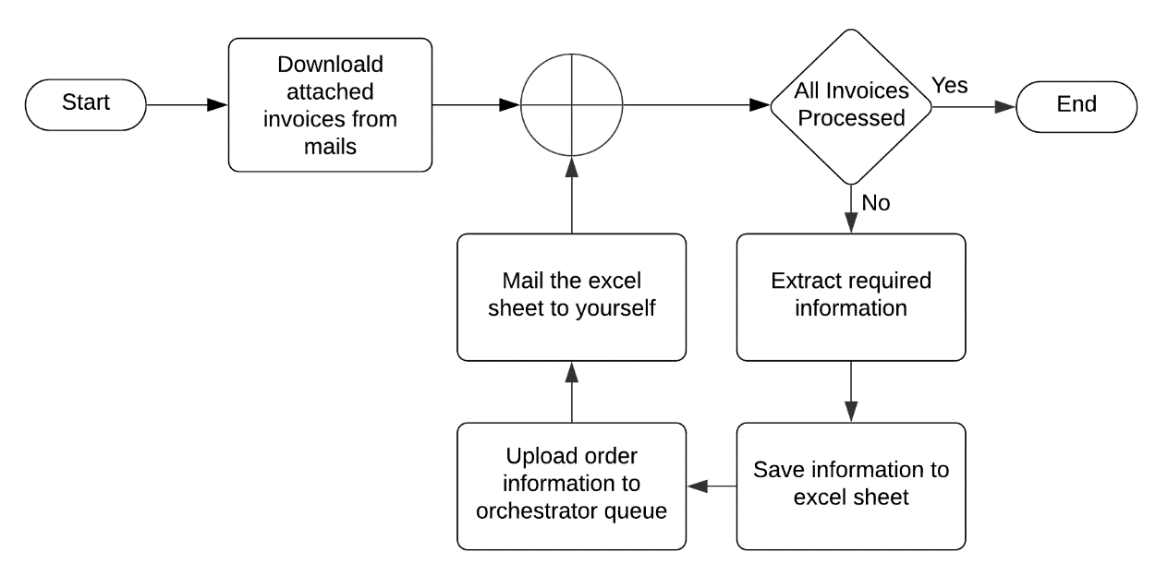

**Detailed Process Map:** This chapter depicts the As-Is business process at a detailed view to enable process owners to document their process

|  |  |  |  |
| --- | --- | --- | --- |
| # | Step Action/Description | Screenshot | Remarks |
| 1 | Open Outlook. | N/A |  |
| 2 | Open unread mail with subject “Techno Computers”. |  | Possible exception: -  Handl exception if no unread mails with the required subject were found. |
| 3 | Save all attachments that follows the following naming convention “CustomerName_InvoiceDate_InvoiceNumber.pdf”. |  | Possible exception: -  Handl exception if no attachments with the naming convention were found. |
| 4 | Open invoice using Adobe. |  |  |
| 5 | Extract the following fields from the document: (InvoiceNo, InvoiceDate, ItemNo, Description, Quantity, Price, SubTotal, GST, Total). |  |  |
| 6 | Close invoice file. | N/A |  |
| 7 | Create an excel file with the following name “CustomerName_InvoiceNumber.xlsx”. |  |  |
| 8 | Save the extracted information into the created excel sheet. |  |  |
| 9 | Upload the following Order Information details to the Orchestrator Queue:  (SubTotal ,GST ,Total) | N/A |  |
| 10 | Mail the excel file as an attachment to yourself with the subject line as  “Course 2 Automation: CustomerName_InvoiceNumber details uploaded to queue” |  |  |
| 11 | Repeat Step 4-10 for the remaining invoices | N/A |  |
| 12 | Successfully end if all the downloaded invoices are processed. | N/A |  |

# To-Be Process Description

## Detailed Process Map

**High Level To-Be Process Map:** This chapter depicts the To-Be automation process at a High Level to enable developers/COE to have a high-level understanding of the to be developed process.

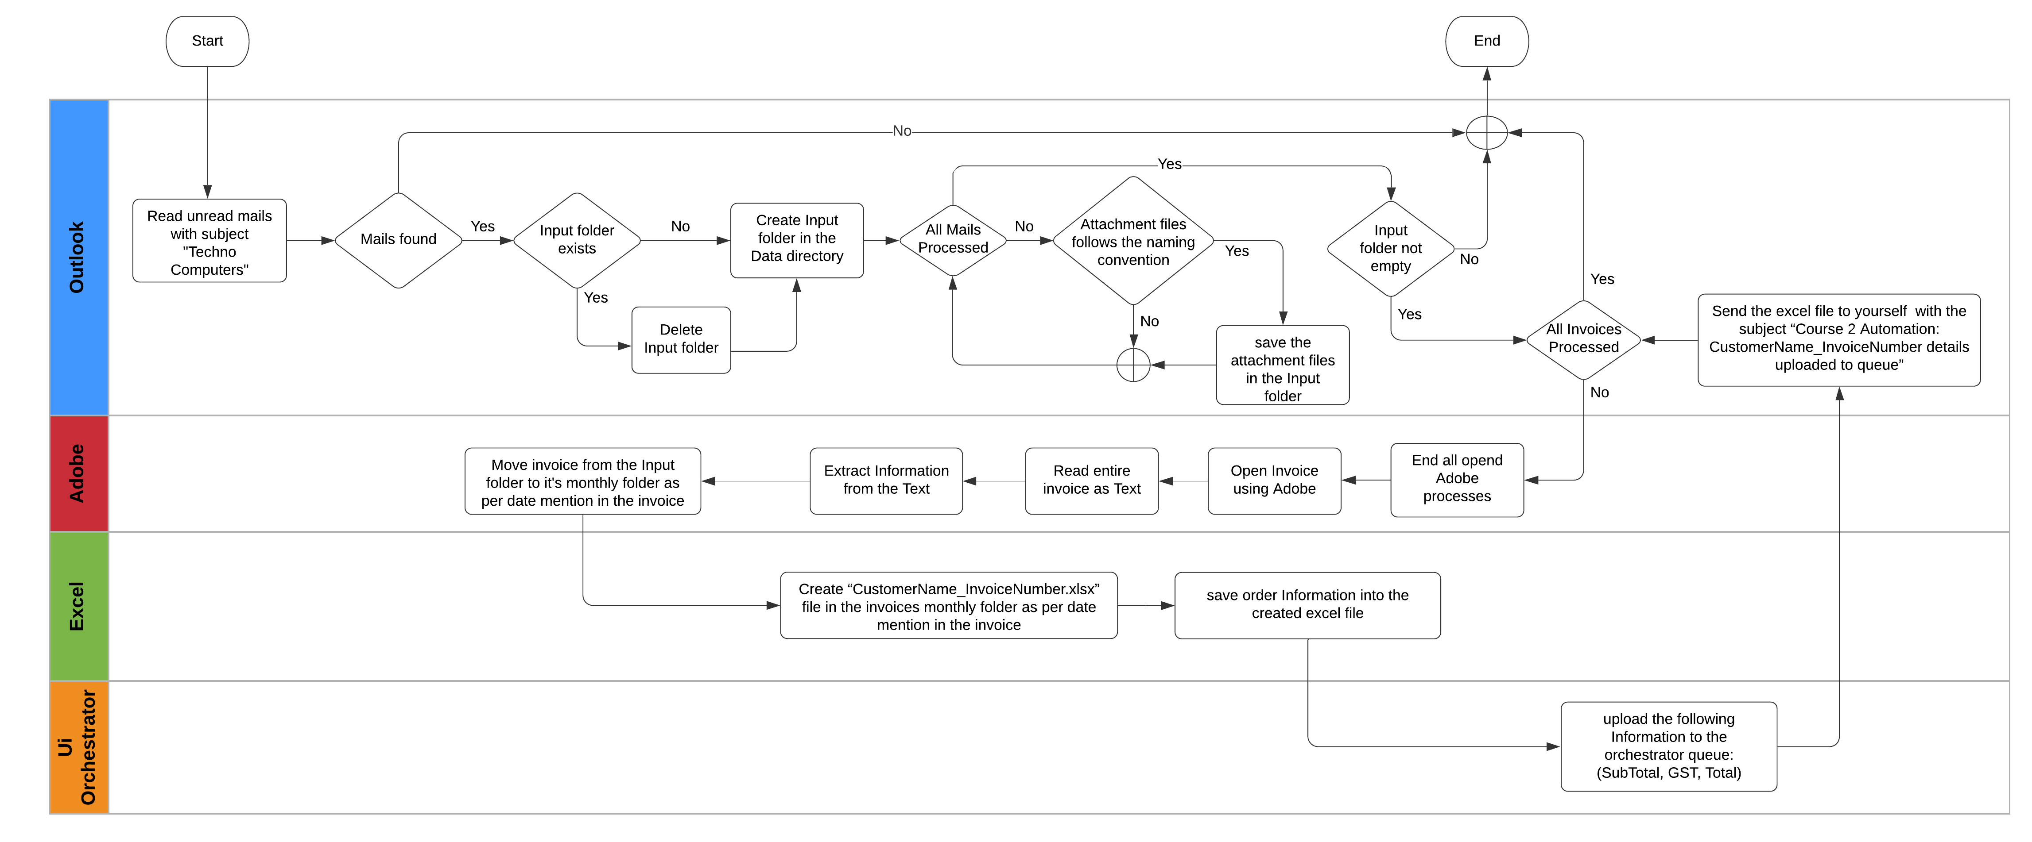

**Detailed Process Map:** This chapter depicts the To-Be automation process at a detailed view to enable developers/COE to see the workflows involved in the RPA solution

|  |  |  |  |  |  |
| --- | --- | --- | --- | --- | --- |
| **Workflow Name** | **Description** | **Pre-conditions** | **Post-actions** | **Arguments** | **Notes** |
| Outlook_DownloadInvoices | In the inbox folder of the passed outlook account, read all unread mails with subject “Techno Computers”, then for each mail, download all the attachments with a naming convention of  “CustomerName_InvoiceDate_InvoiceNumber.pdf” into the Input folder. | The passed outlook account is correct & mails with the required subject are found. | All the correct attachments are downloaded successfully, in the Input folder and ready to be processed. | Input: -  in_OutlookAccount | Handl exception if no unread mails with the required subject were found. Or, if no attachments with the naming convention were found. |
| Outlook_SendInfo | Send a mail to the passed email address, from the passed outlook account, with the passed file as an attachment, the subject line will be “Course 2 Automation: CustomerName_InvoiceNumber details uploaded to queue”. | The passed outlook account is correct & the passed file path is correct. | The mail is sent successfully. | Input: -  in_OutlookAccount  in_AttachFilePath  in_InvoiceNo  in_CustomerName  in_EmailAddress | N/A |
| Adobe_ExtractInfo | Read the passed invoice file as a text, then, extract (CustomerName, InvoiceNo, InvoiceDate, ItemNo, Description, Quantity, Price, SubTotal, GST, Total), from it, then pass all these information as output, and move the invoice from the input folder to its monthly folder as per date mention in the invoice. | The passed invoice file exists. | All the required information is extracted from the invoice successfully, and the invoice is moved to its monthly folder. | Input: -  in_InvoicePath  Output: -  out_InvoiceNo  out_CustomerName  out_InoiceData  out_ItemsLst  out_SubTotal  out_GST  out_Total | N/A |
| Excel_SaveInfo | Build a DataTable to save all the passed information in it, then create an excel file with the passed name.  Then save the DataTable in it. | The passed information isn’t empty. | Information is saved in the excel file successfully. | Input: -  in_ExcelFilePath  in_ItemsLst  in_SubTotal  in_GST  in_Total | N/A |
| Orchestrator_UploadInfoToQueue | Upload the passed information to the passed orchestrator queue. | The passed information isn’t empty. | Information is upload successfully to the passed queue. | Input: -  in_QueueName  in_SubTotal  in_GST  in_Total  in_InvoiceNo | N/A |
| Utility_InvoicesProcessing | For each invoice in the input folder, invoke the required xaml files to process that invoice. | input folder contains the invoices. | All the invoices are processed successfully, and information is uploaded to the queue. | Input: -  in_QueueName  in_OutlookAccount  in_EmailAddress | N/A |
| Utility_KillAllProcesses | Force the termination of the Windows processes representing applications used in the process being automated. | N/A | All the processes name in the passed array -if any- are terminated successfully. | Input: -  in_ProcessesNamesArr | N/A |

## Robot Type

|  |  |  |  |  |
| --- | --- | --- | --- | --- |
| # | Attended | Unattended | Trigger | Comments |
| 1 |  | ✓ |  |  |

## Business Exceptions Handling

The Business Process Owner and Business Analysts are expected to document below all the business exceptions identified in the automation process. These can be classified as:

### Known Exceptions

The table below reflects all the business process exceptions encountered during the process evaluation and documentation. These are known exceptions that occurred before. For each of these exceptions, define a corresponding expected action that the robot should complete if it encounters the exception.

|  |  |  |  |  |
| --- | --- | --- | --- | --- |
| BE # | Exception Name | Step | Parameters | Action to be Taken |
| 1 | No unread mails with the required subject were found. | 2 | N/A | Stop process |
| 2 | No attachments with the naming convention were found. | 3 | N/A | Send a reply to the sender;  Body:  “Hello,  The attachment is incorrect.  Kindly check the attachment and send again.  Thanks”. |

### Unknown Exceptions

For all other unanticipated or unknown business (process) exceptions, the robot should:

* Send a mail to “sheko4rpa@gmail.com”, with the subject line “Course 2 Automation: Business Exception”, and the exception information in the body of the mail.

## System Exceptions Handling

A comprehensive list of all errors, warnings or notifications should be consolidated here with the description and action to be taken, for each, by the robot.

Errors identified in the automation process can be classified as:

|  |  |  |  |  |
| --- | --- | --- | --- | --- |
| SE # | Exception Name | Step | Parameters | Action to be Taken |
| 1 | input folder is empty. | 4 | No invoices found in input folder. | Retry for a maximum of 3 times, then, end process. |
| 2 | Required information not found. | 8 | No information to be saved in the excel file. | Retry for a maximum of 3 times, then, end process. |
| 3 | Excel file -to be attached- doesn’t exist. | 10 | Excel file not found. | Retry for a maximum of 3 times, then, end process. |

For all the other unanticipated or unknown system exceptions, send an email to “sheko4rpa@gmail.com” and attach a screenshot of the error message.

# Other Observations

Include below any other relevant observations you consider needed to be documented here.

* N/A

# Additional sources of process documentation

* N/A